GRADE: IV NAME:
DATE:
WORKSHEET - 7
LESSON -13
WATER RESOURCES

Read the clues and solve the word puzzle.

ACROSS

4 The river on which the
Sardar Sarovar Dam is built

6 A well which draws up
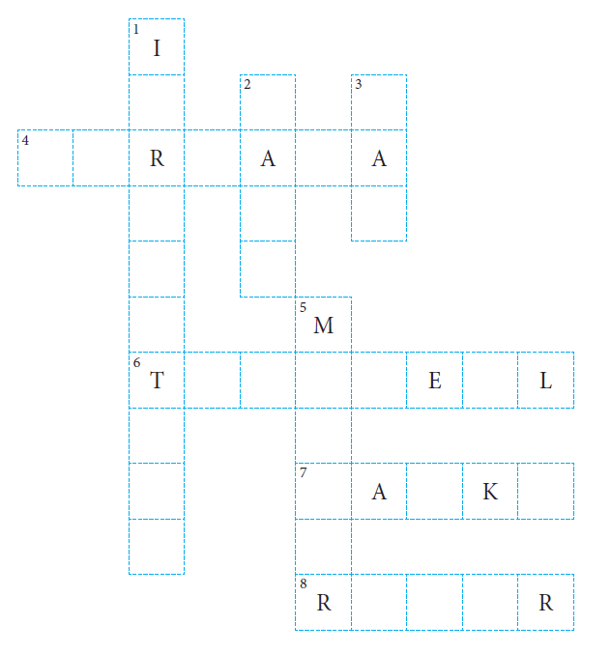
groundwater by sinking
a tube into the ground

7 Low-lying areas in the
southern plateaus that are
filled during the rainy season

8 A water body that originates
in the mountains

DOWN

1 Timely supply of water to crops through tubewells, canals, tanks and sprinklers

2 A body of freshwater surrounded by land that is bigger than a pond

3 A structure built across a river
to control floods

5 The dam built on the Kaveri river

